Solution Case-study: George and Martha

We are having the image file of George’s hard drive and storage media.

For this we use FTK imager tool to analyze the image files and to recover deleted files and to investigate their case so as to find out that they were guilty or not.

Step 1-Launch FTK Imager

Step 2-Select File > Add Evidence Item

Step 3-Select "image file" and proceed to add the file

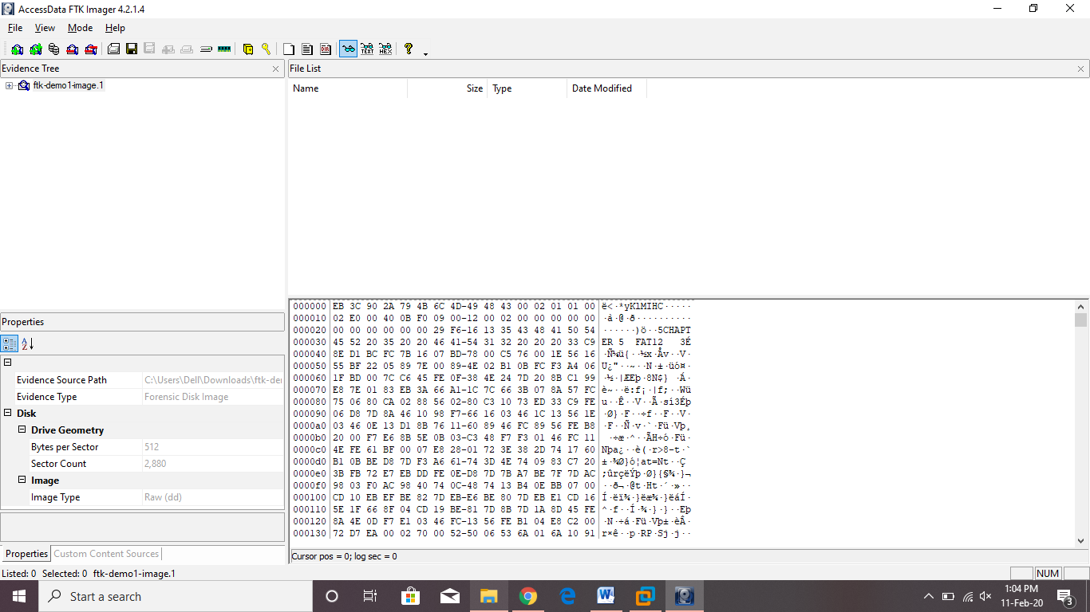

Found some folders and some deleted folders and files in the image file.

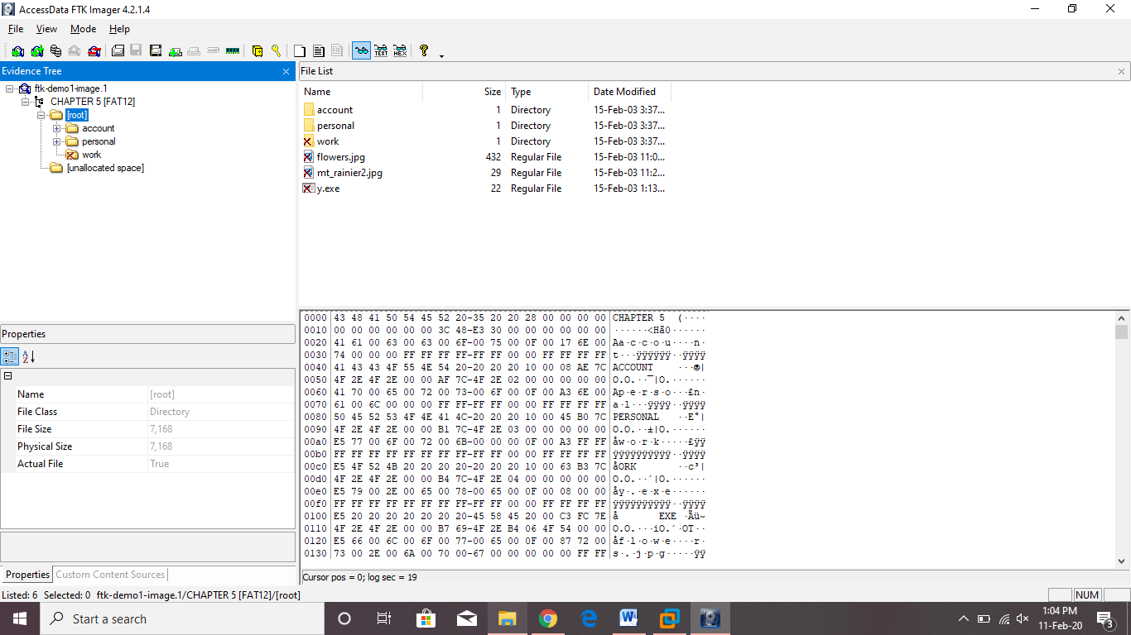

Found some deleted images

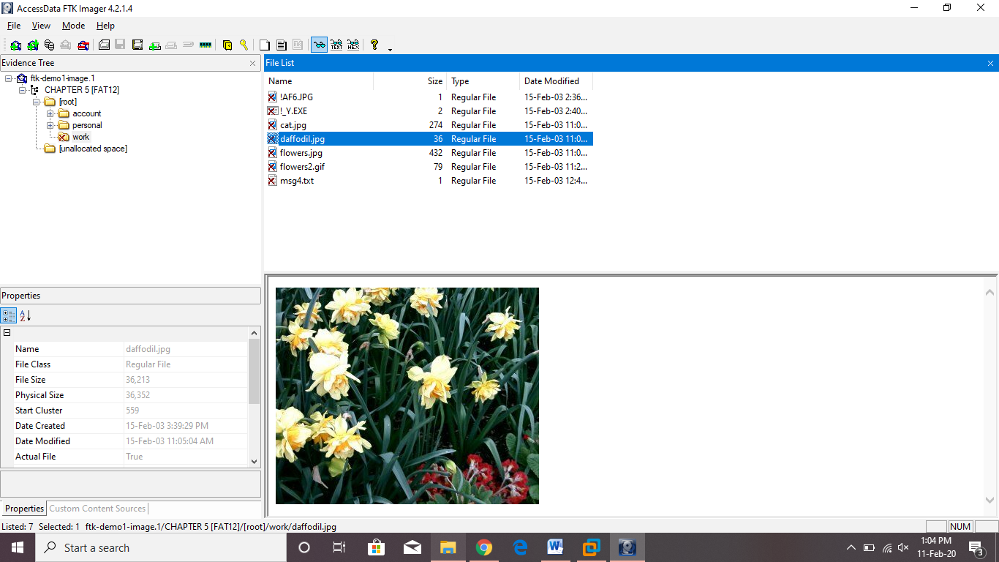

Deleted images (from unallocated space) can be recovered as follow:

Right click on the file>Select Export files>set destination where to save file

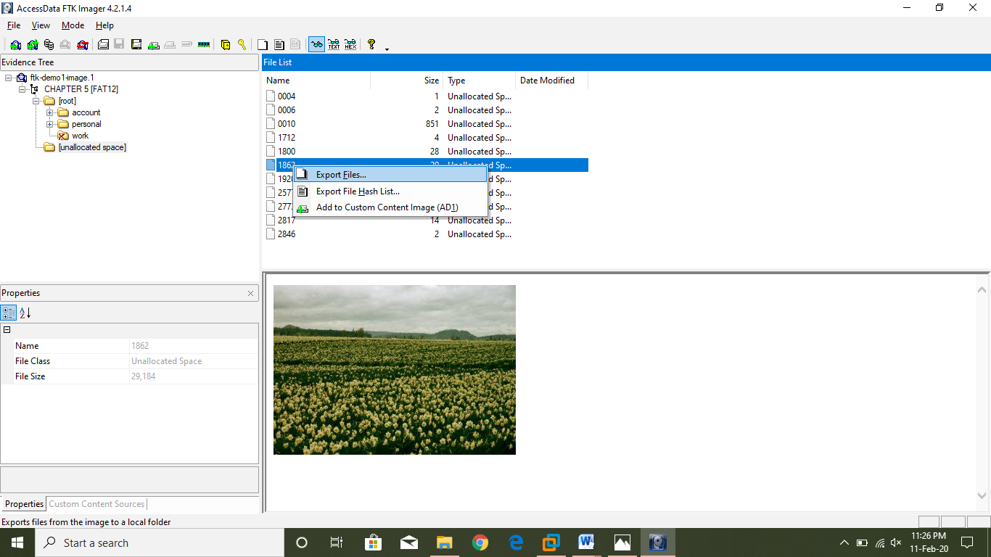

File exports to the saved location.

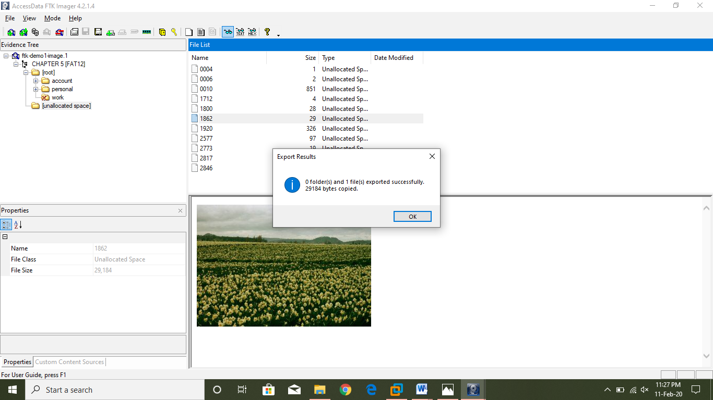

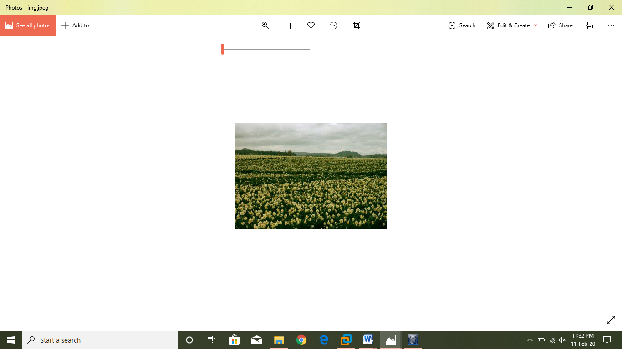

Found some chats between the George and Martha.

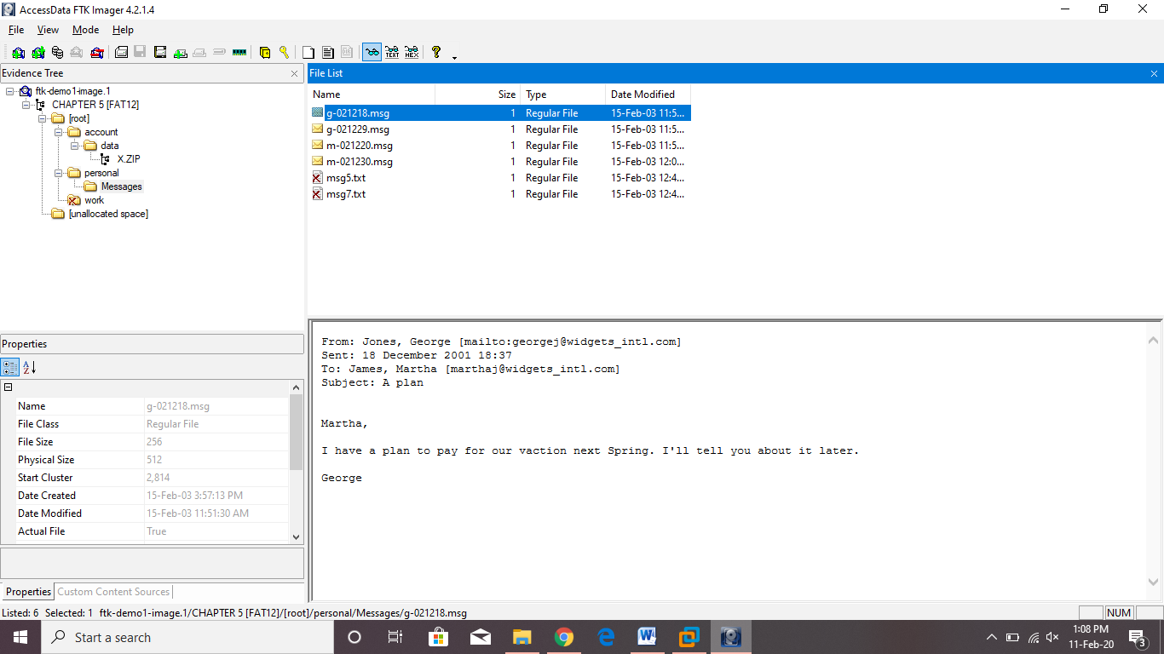

Chats says that on 18 December, George messaged Martha that he has plan to pay for their vacation. They were planning for a spring vacation. Both wanted to go for the mountain vacation and wanted money for the vacation very badly.

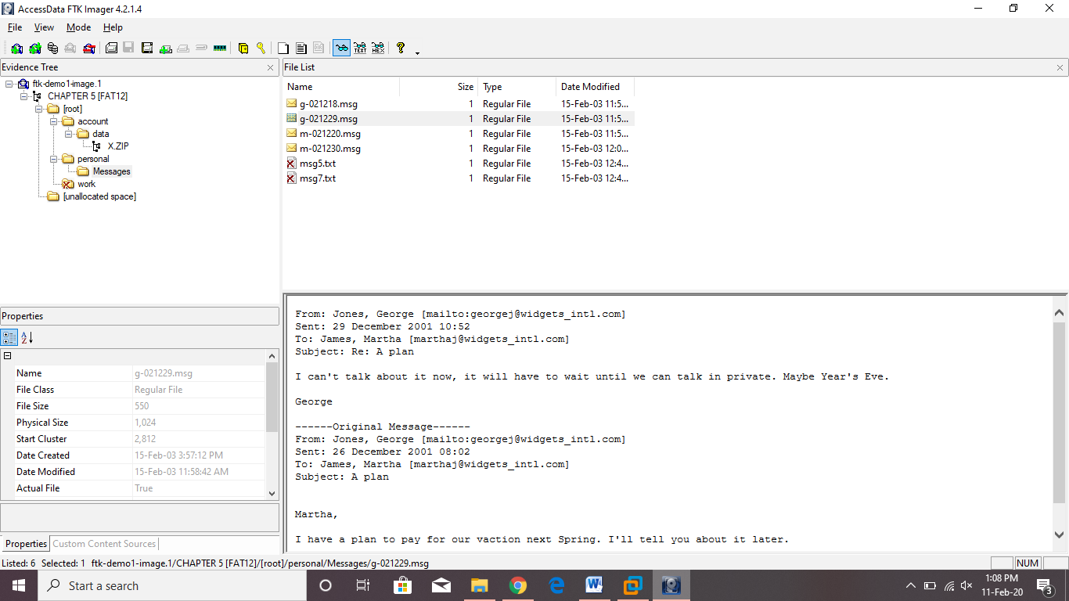

Chats says that they both were planning to transfer the company’s money in their account.



And also, George was ready with the backup plan if the auditor of the company finds the missing money. He told Martha to meet him in Zurich.



For transferring the money, they opened an account in the **Isle of Man Saving & Loan bank.** As I found a secret message from the bank which gives the password of the account.

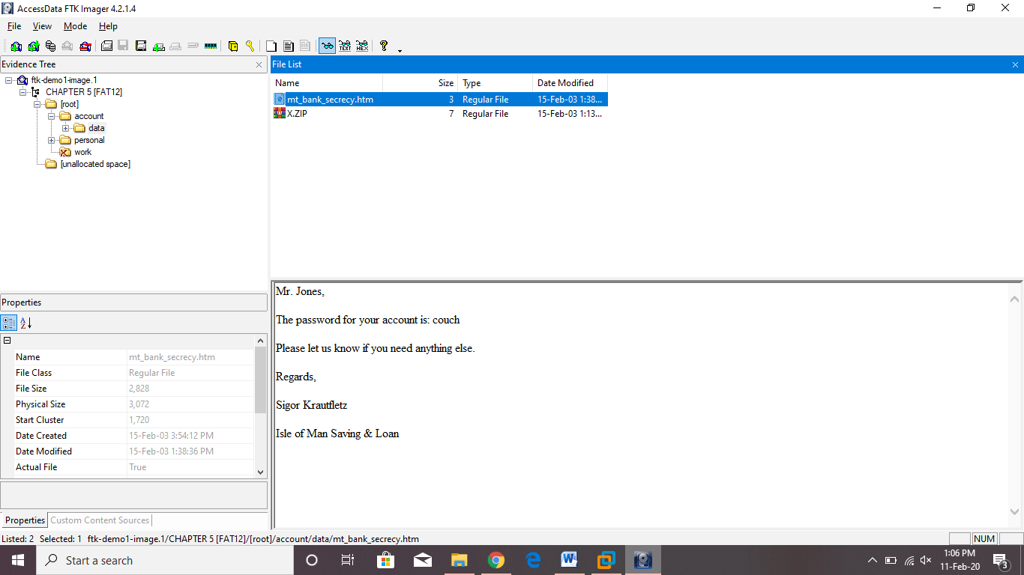

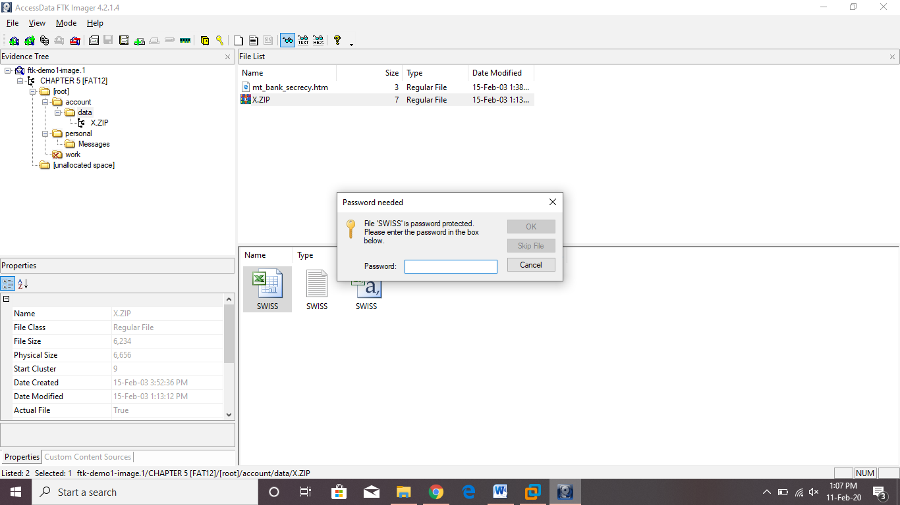

File named SWISS is an excel sheet which can be excessed using the password found. This file contains all the transaction that George made.

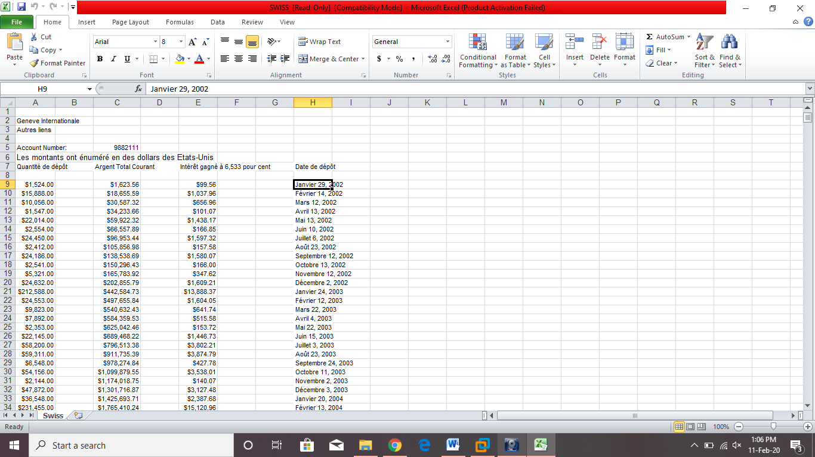

They prove that they both were transferring money to their SWISS account every month. Their account no. is 9882111.

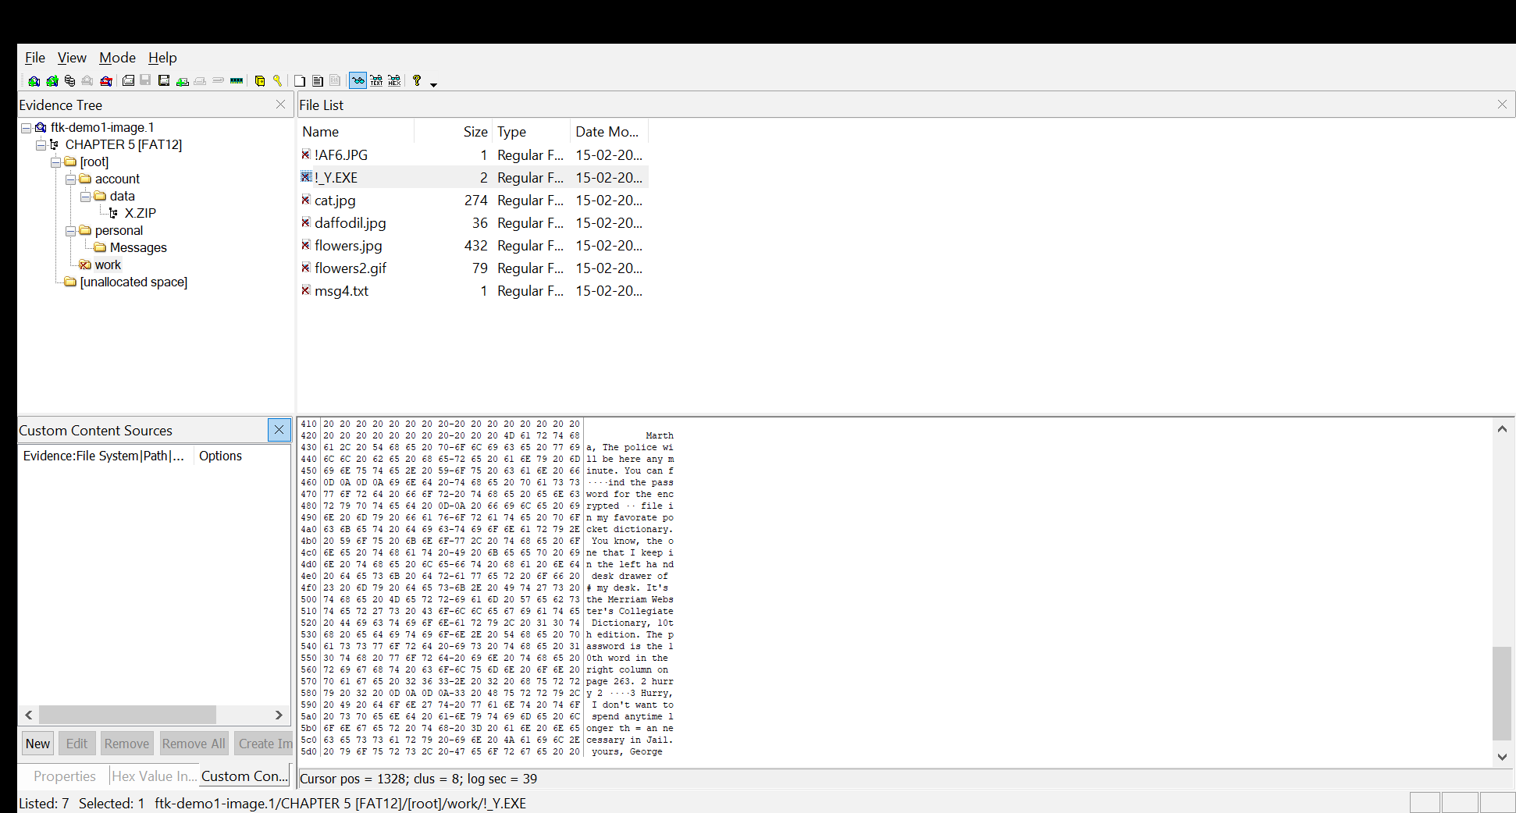

The above message shows that George was afraid of Police and he did not want to go to the jail.

**Conclusion:** I hereby conclude that George and Martha are found guilty as they were stealing company’s money and planning for their vacations. SWISS excel sheet proves their crime along with the chat messages that were shared between them.